Lab 3 Manual:
Inheritance, Polymorphism, Abstract Class, and Interface (C#)

Lab Objectives
- Understand the concept of inheritance in C#.
- Explore polymorphism, method overloading, and method overriding.
- Implement abstract classes and interfaces in practical scenarios.

Walkthrough Task:
Inheritance (Derived and Base Class)
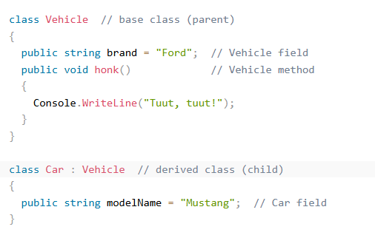
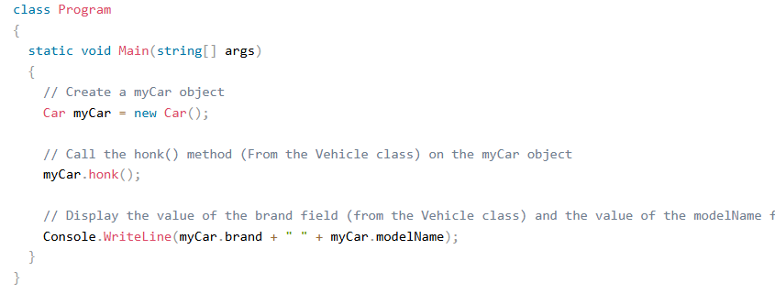
Output:
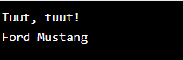

Walkthrough Task
Polymorphism, method overloading, and method overriding
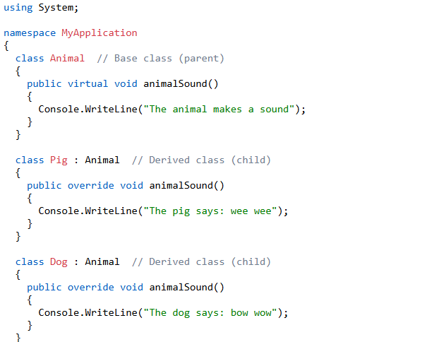

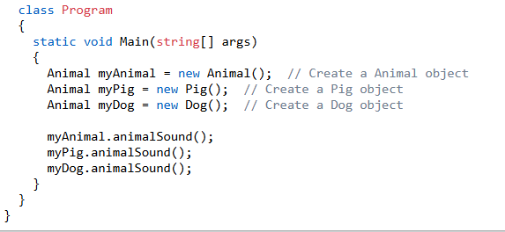
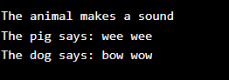

Walkthrough Task:
Abstract classes and interfaces in practical scenarios.
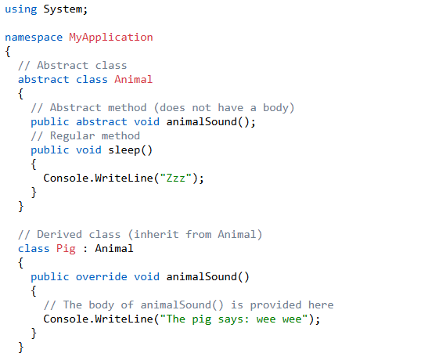
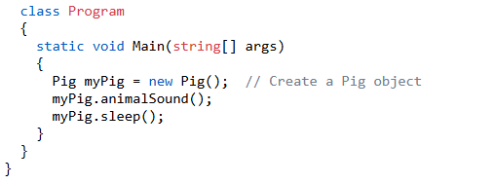
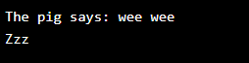

Walkthrough
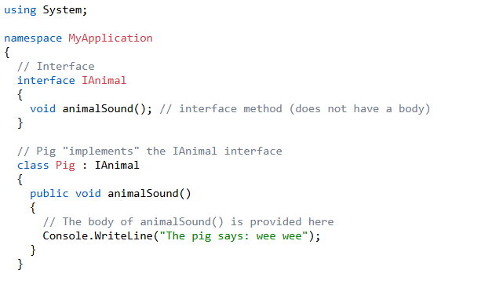
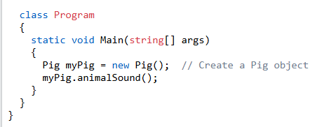
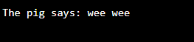

Practice Tasks:

Task1: Write a C# program with the following specifications:
- Create a class named Rectangle that includes:
  - Data members length and width to represent the dimensions of a rectangle.
  - Mutator (setter) and accessor (getter) functions to set and retrieve the values of length and width.
  - A member function recArea() to compute and return the area of the rectangle (length × width).
- Derive a class named Cuboid from Rectangle, which includes:
  - A new data field height in addition to length and width.
  - Mutator (setHeight) and accessor (getHeight) functions to set and retrieve the value of height.
  - A member function cuboidArea() to compute and return the volume of the cuboid (length × width × height).
- Demonstrate the inheritance relationship between Rectangle and Cuboid through class definitions and implementation.

Task2: Design and implement a C# program with the following specifications:
- Create a class named GraduateCourse that includes:
  - Three data members:
    - courseID (e.g., "CS2133")
    - courseName (e.g., "VP")
    - creditHours (e.g., 2 or 3)
    - courseFee (e.g., Rs. 10,000)
  - A parameterized constructor to initialize all data members with values provided by the user.
- Derive a class named ResearchCourse from GraduateCourse, which includes:
  - An additional data field: experimentFee
  - A parameterized constructor to initialize experimentFee along with the inherited data members from the base class.
  - A member function setExperimentFee() to modify the value of experimentFee.
  - A function display() to show the values of its own attributes along with those of the base class.
  - A function totalFee() to compute and display the total fee (courseFee + experimentFee) for a particular course object.
- In the Main() function:
  - Create an instance of the ResearchCourse class.
  - Invoke appropriate functions to display all attribute values.
  - Display the total fee for this particular instance.

Task3: Design and implement a C# program with the following specifications:

- Create a base class named Animal that includes:
  - A virtual function eat(string food) to represent a general eating behavior.

- Derive three classes from Animal:
  - Herbivore (e.g., deer, cow)
  - Carnivore (e.g., lion, tiger)
  - Omnivore (e.g., bear, human)
  - Each derived class must override the eat() function to display a message indicating the type of food that animal prefers.

- In the Main() function:
  - Create instances of Herbivore, Carnivore, and Omnivore.
  - Invoke the eat() function on each instance, passing an appropriate food string as an argument to demonstrate polymorphism.

Task 4: Design a Vehicle Management System using abstract classes and interfaces in C#.
- Create an abstract class named Vehicle with the following:
  - A protected data member speed.
  - An abstract method Move() to define vehicle movement.
  - A concrete method DisplaySpeed() to show the current speed.
- Implement two derived classes:
  - Car: Implements Move() to display "Car is moving on the road."
  - Boat: Implements Move() to display "Boat is sailing in water."
- Define an interface IFuelEfficiency that declares:
  - A method CalculateFuelEfficiency() that returns fuel efficiency as double.
- Implement IFuelEfficiency in both Car and Boat, where:
  - Car calculates fuel efficiency based on mileage.
  - Boat calculates fuel efficiency based on fuel consumption rate.
- In Main():
  - Create objects of Car and Boat.
  - Call Move(), DisplaySpeed(), and CalculateFuelEfficiency() for each.

